PRESS RELEASE

Extreme Coatings – a service of Surface Engineering & Alloy at K, Hall 13, Stand B91-5
Wear resistant tungsten carbide coating of plasticizing feedscrews as highlight

Extreme Coatings, the leading global brand of tungsten carbide coating for plasticizing feedscrews, parallel and conical twin feedscrews and continuous mixing rotors, will present their full range of products and services at K 2010 Hall 13, stand B91-5. Visitors will see samples of tungsten and chromium carbide coatings as well as detailed exhibits that explain how carbides provide two to five times longer equipment life.

Facts and Data
With more than thirty years of experience in the field of wear resistance and welding alloys, Surface Engineering and Alloy of St. Petersburg, Florida USA, is one of the leading experts in its field. Under the Extreme Coatings brand, it applies its expertise and technology to highly complex surfaces such as the flights of feedscrews. As Curt Kadau, president of Surface Engineering & Alloy explains “our customers, the feedscrew manufacturers were seeking more wear resistant materials from which to manufacture plasticizing components. We took an existing idea and perfected it. Thermal spray application of hard carbides is the most cost effective method to improve surface wear characteristics. The difficulties have been coating adhesion, polishing the hard carbide material and completing the work in a timely manner. We first determined why other coatings failed and corrected those errors. We then developed a diamond polishing media to achieve a mirror finish and last we specialize in coating feedscrews so our work is complete in 10 days or less”, explains Kadau.

How to judge wear resistant materials?
Carbide type and volume percentage are the two most critical factors that influence wear resistance of a material. Tungsten carbide has a Vickers hardness of 2200 (comparable to 85 Rockwell C) and our standard XC1000 contains more than 80% by volume of these hard particles. Standard alloys contain softer chromium carbide and usually less than 35% carbide by volume.
Harder materials exist, however surface thickness achievable or coating bond strength do not match that of tungsten carbide.

Components that can be coated
Greg Quinn, Extreme Coatings Product Manager describes the evolution of capabilities in surface coating. “Initially we offered two thicknesses and complete encapsulation of a feedscrew surface. While this is the gold standard for coating, not everyone requires this level of protection. We developed FliteGuard for extrusion screws which allows for coating of just the flight tops. FliteGuard adds three to five times longer service life at a lesser cost.”
“Twin feedscrew geometry is a coating challenge”, says Quinn. “Through innovative spray nozzle adapters we now provide full encapsulation of complex shaped feedscrews.” A coated set of 87 mm parallel twin feedscrews were recently examined. Past nitrided screws and barrel were replaced after 2000 hours of operation while this coated set had only 0.15 mm (.006”) of total diametrical wear after 4000 hours operation. “The customer was astonished with these results and immediately commissioned six sets of feedscrews to be full coated.” remarked Mr. Quinn.
Some applications require a metallurgical bond to protect a surface. “For this we have developed a fusible grade of coating that allows for a metallurgical bond after coating”, states Mr. Quinn. The two materials become welded after high temperature fusing and components like compounding screw elements, non-return valve check ring/seat, thermo-set feedscrews, and other parts where impact can be expected can now receive the high wear protection of tungsten carbide.

One of our agents, Groche Technik, will exhibit Extreme Coatings feedscrews in hall 13, stand D 60.

Photos (Thomas Kvinge)
- High surface finish of full encapsulation feedscrew

Text: 3846 characters (with spaces), 590 words.

Ref: 10-88-01, July 2010

Surface Engineering & Alloy
Tom Kvinge
2895 46th Ave No.
St. Petersburg, Florida 33714
USA
Tel. ++1 727 528 7998 x 113
Fax. ++1 727 528 7995
info@extremecoating.com
www.extremecoating.com
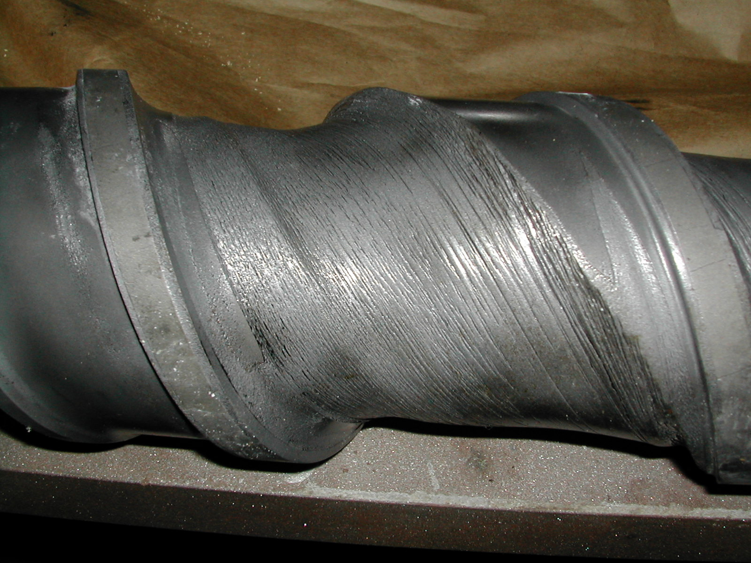
Worn 105 mm feedscrew 40% glass filled nylon

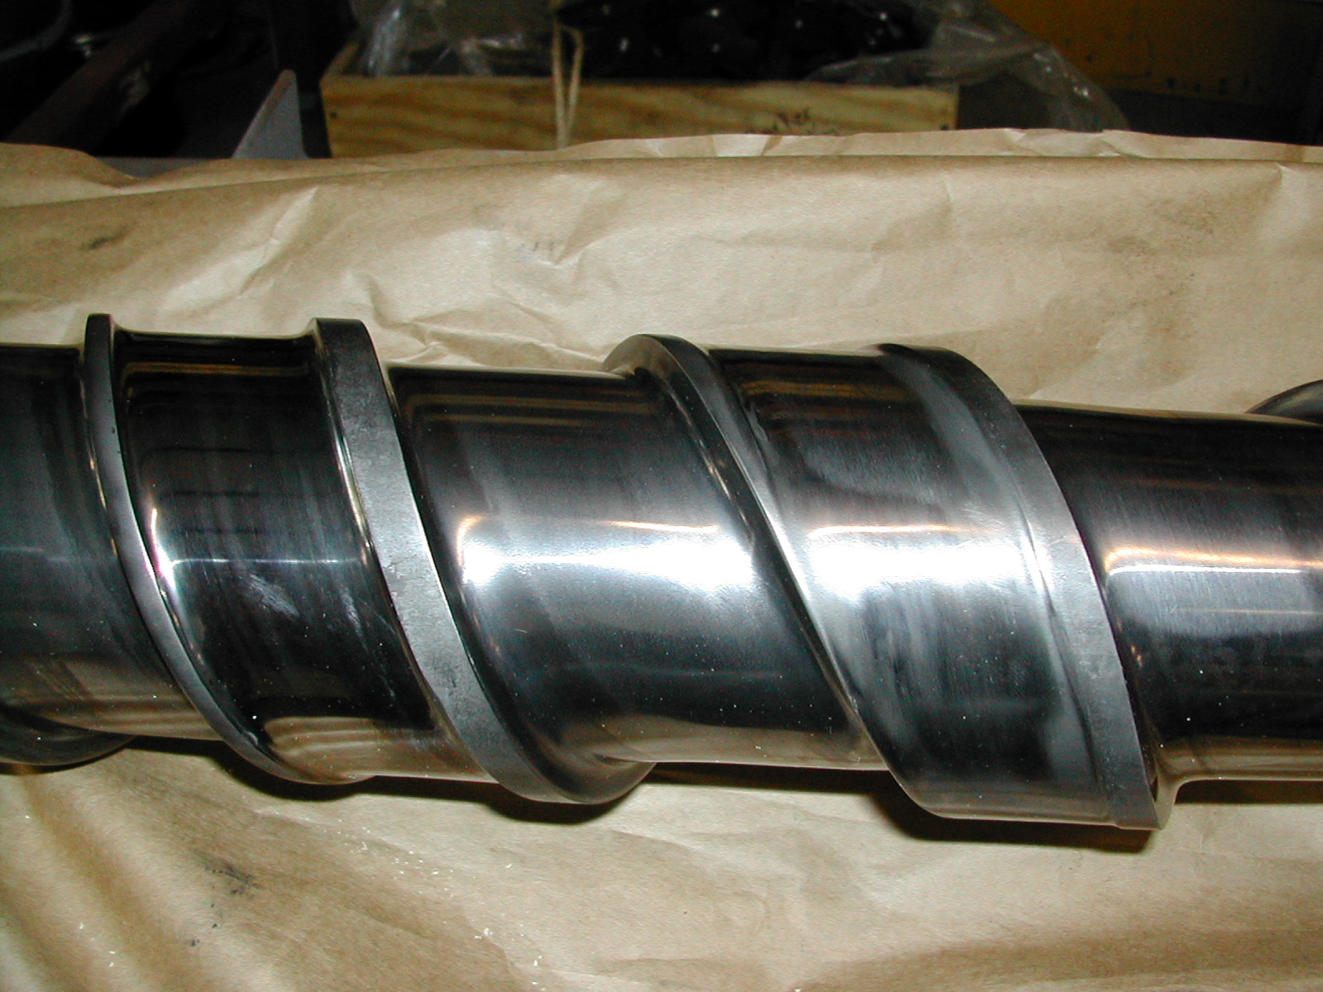
Carbide protected 105 mm feedscrew 40% glass filled nylon

