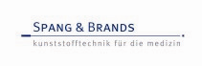
Press Release

MEDTEC firmly in view – Spang & Brands achieves DIN EN ISO 13485 certification
High level of EU qualifications reached for the manufacture of medical devices

The production of medical devices is subject to a number of the most stringent regulations and conditions. “Certification DIN EN ISO 13485 is an indispensable prerequisite for the qualified production of complete systems, such as the mixing and dosing systems for bone cement (picture),” explains Friedrich Echterdiek, managing director at Spang & Brands GmbH based in Friedrichsdorf, Germany. The company, renowned manufacturers of plastics components for medical and pharmaceutical use, has reached this high level of qualification within the framework of a consistent corporate strategy. This achievement was reached in December 2012, after almost a year of intensive preparation and appropriate reorganisation. The German testing, auditing and certification authority TÜV-Süd carried out auditing and certification. “Following the success of these measures, we are now able to offer customers and other systems suppliers in the medical and pharmaceutical industries our significantly broader spectrum of development and products at MEDTEC (Spang & Brands, stand 1 M 49) in order to provide complete ready-to-use systems and primary packaging,“ continues Echterdiek.

During MEDTEC – February 26 - 28, 2013, Stuttgart, Germany - the company will exhibit more than 50 different medical products, i. e. component groups, precision and micro products manufactured in mono or multi-component injection moulding technology. Among the exhibits are syringes, cannulas, push-through membranes, implant components and those for minimally invasive medicine, fastening/joining elements, functional parts for infusion solution bags and closure/sealing systems, as well as assembled units and ready-for-sale devices where accuracy and structure must be – and is – exemplary.

On the whole, Spang & Brands uses very particular plastics blends, including resomere materials, those that can only be processes using state-of-the-art high-performance moulds: “For the past 30 years or so, we have specialised in precision and clean-room injection moulding for the medical and pharmaceutical industries …,” states Friedrich Echterdiek, and continues “… for just those special ISO 13485 relevant projects, we employ the right technologies with CAD-3D development and MoldFlow analysis. We have more than 50 active injection moulding machines – including all-electric machines. Most importantly, we take full advantage of our continuously growing engineering know-how.“ In Class 8 clean-rooms (100,000), fully automatic and manual assembly takes place, not forgetting the packaging of components and assembly units ranging, from pilot/preproduction series and just-in-time produced batch sizes right through to runs of many millions. Strategically positioned checkpoints and 3D precision metrology support the company’s stringent quality surveillance and assurance system.

“The demand for smaller, more complex and more accurate functional components is continuing to rise – this is particularly relevant in medical technology. During MEDTEC, we will demonstrate that we master the corresponding technologies, those regarding, among others, the development of components, mould making, injection moulding technology, the topic of clean-room production, and assembly, in other words the complete spectrum of production processes within the entire value-added chain”, emphasises and concludes Friedrich Echterdiek.

Photos: www.pr-portfolio.de
Text: 3552 characters (incl. spaces), 492 words
Ref.: 13-16-01, January 2013

Further information: Friedrich Echterdiek, Spang & Brands GmbH, Max-Planck-Straße 25, D-61381 Friedrichsdorf
Tel.: +49 (0) 6172 – 95 700, Fax: +49 (0) 6172 – 95 70 70, website: www.spang-brands.de

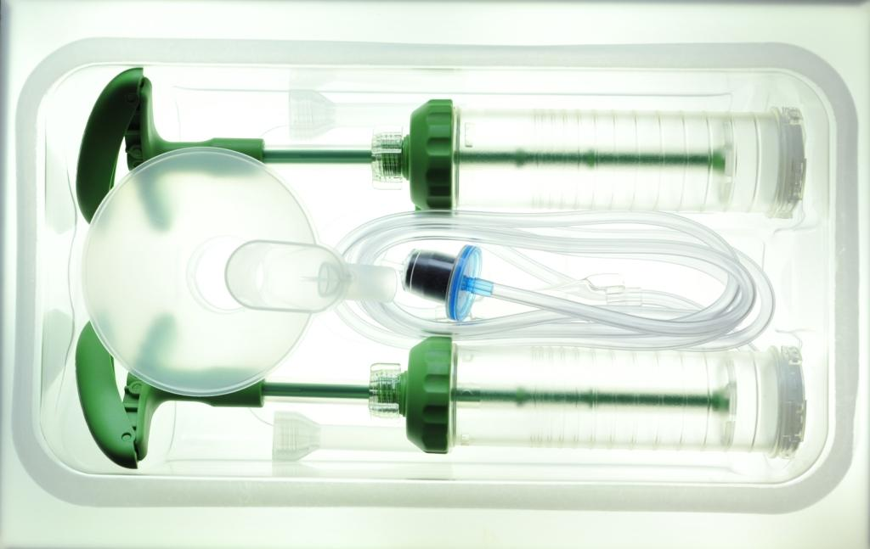
Mixing and dosing system for bone cement

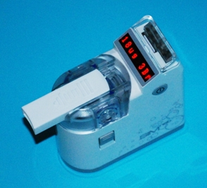
Inhaler

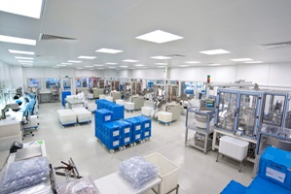
Cleanroom – Assembly

Photos: www.pr-portfolio.de

Ref.: 13-16-01, Januar 2013

Further information: Friedrich Echterdiek, Spang & Brands GmbH, Max-Planck-Straße 25, D-61381 Friedrichsdorf
Tel.: +49 (0) 6172 – 95 700, Fax.: +49 (0) 6172 – 95 70 70, website: www.spang-brands.de

