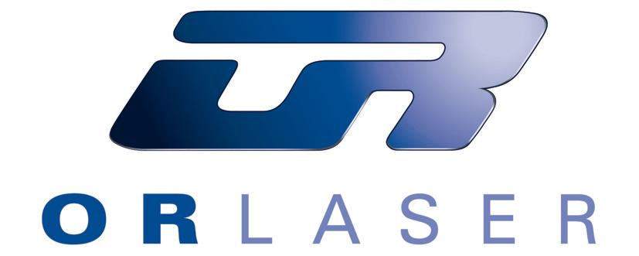
Press release

Portable IQ Laser significantly reduces tool repair times through inline laser repair

Production tools often have to be demounted with considerable effort, even due to small defects. This problem belongs to the past. Extremely compact Nd:YAG laser welding equipment with a basic footprint of 0.2 m² now comes to the rescue: “our newly developed IQ Laser which we introduced worldwide not long ago, can also be ‘borne’ in terms of the investment costs” says Eitan Reznik, Sales Manager Germany at O.R. Lasertechnologie GmbH in Dieburg, “as it has a short ROI period thanks to the inline repair technology”.

As Eitan Reznik explains, the prototype of the IQ Lasers with the innovative concept of inline laser repair was presented in December 2009 at the EuroMold fair. “Our customers were enthusiastic”, Reznik recounts. A small void or mold flash often results in complete shutdown of the entire production process: it is here that the IQ Laser is used for local laser welding and can show its strengths as a successful addition to mobile equipment.

“It takes a lot of effort to weld a 10-tonne injection mold in a conventional way” Eitan Reznik explains. Investigations have shown that around 15 hours are needed for mold demounting, transport, handling, actual welding, post-welding work, the spotting press and mold remounting. In addition to all of this, there is downtime of the injection molding machine, as well as costs of transport, etc. Everything goes much faster with repair by the IQ Laser. “It takes 15 minutes to position the IQ Laser directly at the injection molding machine, laser treatment half an hour, post-welding work directly at the injection molding machine and restarting the machine a further one and a half hours. That makes together 2.5 hours – instead of 15!”, Eitan Reznik states. Productivity rises and with it also the profit. In a direct comparison with standard repair, the IQ Laser is the clear winner, with the same repair result.

With an average power of 55 watts, peak pulse performance of 6 kW and pulse energy of 60 Joule, application possibilities of the IQ Laser are almost unlimited. The compact IQ Laser finds its classic use in mold and tool making, but inline laser welding in aircraft construction or in the energy sector are also entirely normal applications for the equipment.

“Injection molding companies comprise 90 percent of our customers. Due to its inline repair, our IQ Laser is as fast as the fire brigade and saves users a lot of time”, Reznik says. Customers such as the company VORWERK confirm this: “small defect, big effect”, reports Alexander Popov, Manager of the toolmaking department at VORWERK in Wuppertal. “Two days downtime with the 5 tonnes heavy injection molding tool for plastic appliance housings and downtime costs in the range of four digits of Euros are quite normal. With the IQ Laser we have been able to weld directly in the tool with a 0.2 mm welding wire – the small 0.1mm weld bead has been polished off just by hand – and perfect parts came of the injection molding machine again two hours later”.

O.R. Laser has a total staff of 60 employees in the main location in Dieburg, Germany, and in the four subsidiaries in the USA, Turkey, Israel and Romania – as well as 30 partners in all continents. Its IQ Laser product is without any worldwide competition. This is also because the easy operation of the IQ Laser can be learnt rapidly, even by experienced TIG (tungsten inert gas) welders. It is sufficient to set performance, frequency and pulse time and the laser can be already brought into operation. The focus can be set between 0.2 and 1.2 mm directly on the hand-held welding head. Pulse time can be varied from 0.2 to 30 milliseconds, depending on the 1.0 to 20 Hertz pulse frequency. The full range of laser welding wires in diameters from 0.2 to 0.5 millimetres can be used. Reznik says: “we get our customers to learn handling of the IQ Laser within one hour. Welding can be done by practically anyone”. The welder watches the work as it progresses via a 10” touch-screen display on which all laser parameters are also displayed. The camera image has 10x magnification and shows the operator the precise point of contact of the laser via a crosshair in the display.

The safety required in the working environment is guaranteed by a sensor built into the hand-operated welding head that monitors the situation and contact with the component being welded. The operator can only set off the laser beam once there is an obvious distance to the work area. This ensures that the welding points remain constantly small and precise. The required laser energy is applied to a point of just 0.4 mm within several milliseconds. Additive material is melted together with the base material within the shortest possible time, and unnecessary heat input into the mold is avoided thus preventing cracks or deformation. Laser welding takes place with a contour that closely follows the required end result, so that subsequent work is reduced to an absolute minimum.

The IQ Laser is a perfect complement to the O.R. Laser range of products. There are a total of five different sizes of the Nd:YAG (solid state) laser available, whereby the largest equipment has laser power of 300 watts. All of these laser systems are produced at the company’s headquarters in Dieburg – from development with the most modern CAD/CAM equipment right up to the final finished laser equipment. O.R. Laser has a high degree of vertical integration and draws upon renowned global producers for additional components needed to complete its equipment. Aside from European markets and the USA, O.R. Laser is now focussing increasingly on the BRIC countries (Brazil, Russia, India, China). “India is an absolute boom region for us, while we have been supplying China already since 2004” states Sales Manager Reznik. Three distributors are already operating in India; an own office will be opened there shortly. There are furthermore an additional two new distributors operating in South Africa. And O.R. Laser is also expanding at its German location in Dieburg. Three further specialists have been engaged here in August. The company’s building will be extended soon with an additional floor.

Text: 6241 characters (incl. spaces), 1041 words
Photos: (O.R. Laser)
Ref: 10-33-01, October 2010

